HARDWARE PROTOTYPE OF FLOUR MILL MOTOR CONTROL USING PWM

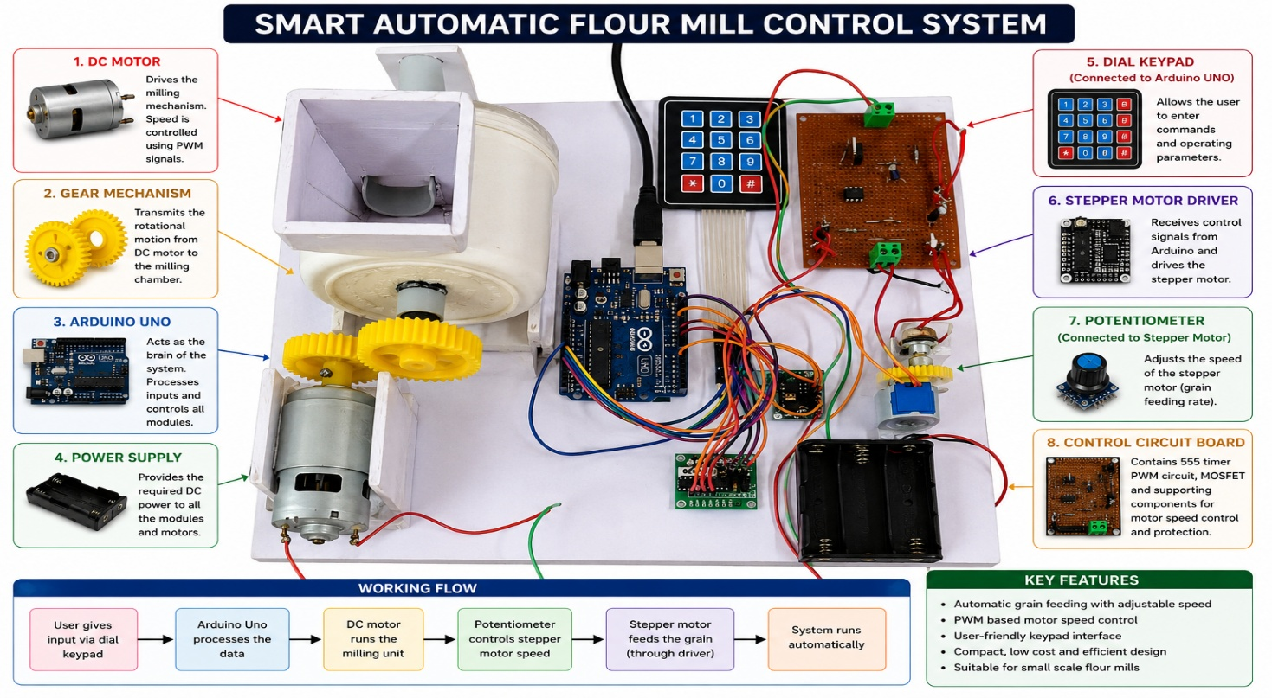
Working Principle
The Arduino Uno controls the stepper motor. When the Arduino sends pulses, the stepper motor rotates. The shaft of the stepper motor is mechanically coupled to the potentiometer. As the stepper motor rotates, it turns the potentiometer shaft, changing the potentiometer resistance. This varying resistance changes the PWM duty cycle in the PWM control circuit. The PWM circuit then controls the speed of the DC motor. Therefore, the rotation of the stepper motor indirectly controls the speed of the DC motor through the potentiometer and PWM circuit.
Explanation for Report
"The Arduino Uno controls the rotation of the stepper motor. The shaft of the stepper motor is mechanically connected to a potentiometer. As the stepper motor rotates, the potentiometer position changes, varying the PWM duty cycle generated by the PWM circuit. The PWM signal is then used to control the speed of the DC motor. Thus, the DC motor speed is automatically adjusted according to the position of the stepper motor."

